Category.6A Field Termination Coupler & 24 Port Coupler & 24 Port Coupler Mounting Panel

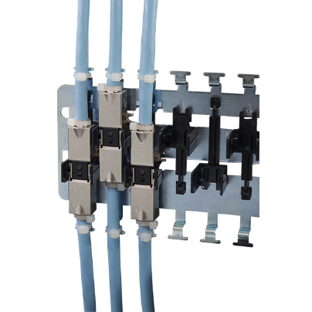

Cat.6A Field Termination Coupler enables cable to be extended with minimal effort and remain the excellent transmission performance at field installation. Ideal for using as consolidation point in direct connecting instead of intermediate patching. It also make unused cables to be reactivated and extended to the next required connection.

Features

Metal Housing: Zinc Alloy with Nickel plated

IDC at both end to accept solid cable from 22AWG-26AWG

IDC to IDC design maintain the transmission performance better than via RJ45 patch lead

Housing with screw holes make it easy to be screwed on channel duct or other surface

A 2U 24-port empty panel is available for rack mount application

Ordering Information

|  |  |
| --- | --- |
| PART | Description |
| CP8FZXTA | Cat.6A Field Termination Coupler, STP |
| CP8GZXTA | Cat.6A 10G Field Termination Coupler, STP |
| PME2400S0 | 19” 2U mounting panel for CP8FZXTA, STP |
| ME12400S0 | 19” 2U mounting panel for CP8GZXTA, STP |